1. Sigmoid

Training acc increases as the number of epochs increased. First validation acc increased then it became slightly linear as number of epochs increased.

Validation loss increase as the number of epochs increased as the training loss decreased.

1. Relu

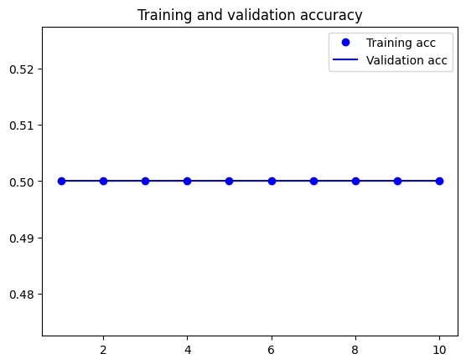

Training acc and validation acc are flat per the number of epochs increased. Training loss decreased as the number of epochs increased while validation loss increased per increased number of epochs.

1. Tanh

Training acc increase as the number of epochs increased. Validation acc started to increase then it became to decrease as the number of epochs increased. Validation loss increase as the number of epochs increased with up and down graph. Training loss increased while number of epochs increased.

1. Linear

Training acc increase as the number of epochs increased. Validation acc started to increase then it became to decrease as the number of epochs increased. Validation loss increase as the number of epochs increased with the linear line graph. Training loss increased while number of epochs increased.

1. All activation functions graphs together for comparison

You can simply compare all graphs behavior as needed. All information of each graph discussed above.